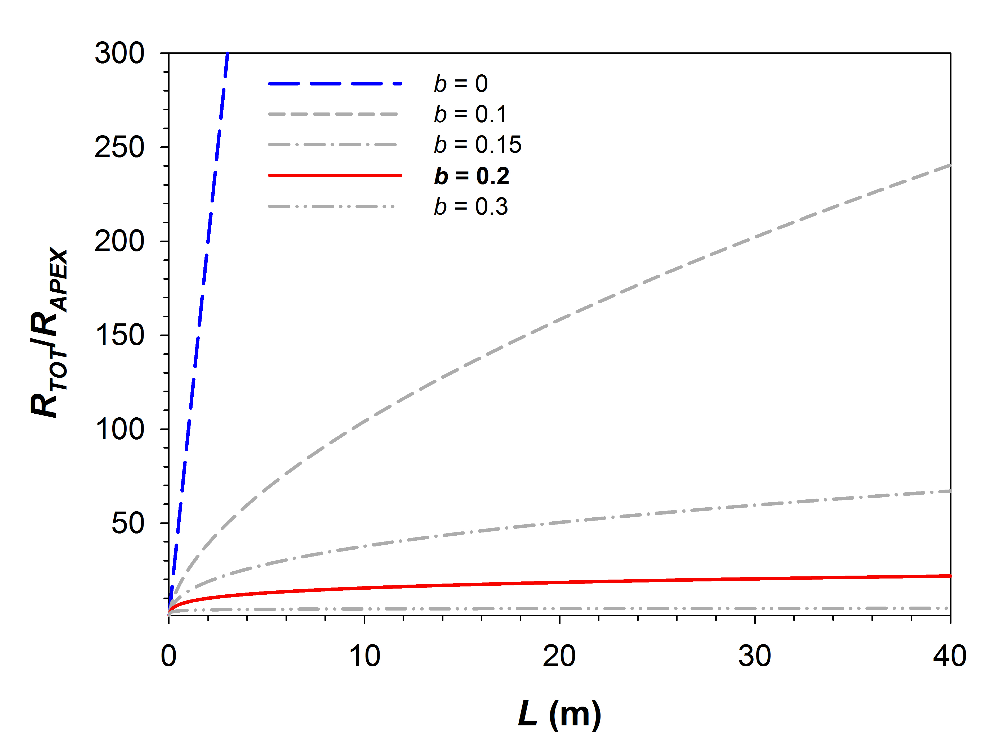
Figure S1 Variation in tip-to-base vessel widening rate and relative hydraulic resistance with stem length. Different degrees of vessel widening, expressed by the scaling exponent b, determine different values of total hydraulic resistance that increases with length (L) in a single pipeline, relative to the resistance of the most apical conduit (R_{TOT}/R_{APEX}) calculated using Poiseuille’s law assumptions. L can be thought of as tree height or liana stem length. Different values of b lead to different rates of accumulation in resistance with length. Values of b lower than about 0.2 imply vessels that widen slowly tip to base, as well as increases in hydraulic resistance with increasing L. The slower the rate of widening, the faster resistance increases (the line with the steepest slope represents a cylindrical conduit). Values far above 0.2 will lead to stems with very wide vessels for a given stem size, leading to overly large body mass and amount of fluid relative to leaf area supplied (Banavar et al. 1999) as well as inviting embolism. Values of 0.2 or slightly above provide constant hydraulic resistance with increases in L (denoted by the almost perfectly horizontal curve), while allowing for maximally safe and efficient conductive systems. As a result, given heritable variation in vessel scaling exponents, selection is expected to favor values of b that are close to 0.2 or only slightly above regardless of phylogenetic affinity, habit, or climate.

